How to Use Encrypted Mail Feature in Outlook
There is a new add-on for Microsoft Outlook that is provided by our mail security company (Barracuda Networks). This add-on allows you to send a private encrypted message for enhanced security. To use this new feature, follow the steps below:
- Open Microsoft Outlook
- Click on the “New email” button to create a new message

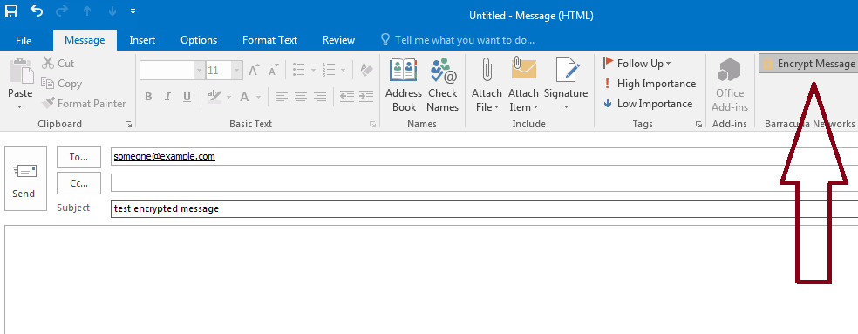
- You should see the “Encrypt Message” option in the section for Barracuda Networks
- Click on this option, and send your message
- The recipient will receive the following message
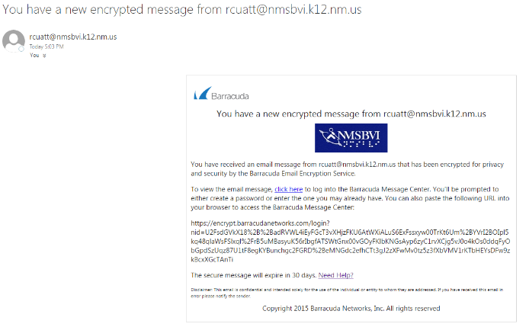
- The recipient will then follow the directions in the e-mail to retrieve the encrypted message from the secure portal.
